Temasek Polytechnic
School of Informatics and IT

Diploma in Information Technology (IT)

Software Requirement Specifications (SRS)

Project Particulars

Tutor | Mr. Mel Goh
Class | P01
Project Title | Delonix Regia Hotel Management System

Project Team’s Particulars

Matric Number | Student Name
1505052I | Lim Cai Feng
1505033I | Ekaterina Utkin
1506102A | Nur Syafiqah
1504658D | Jiang Feng

Revision History

Date | Version | Description | Author
20/05/17 | 2.4 | Add/ Update of functional requirements | Ekaterina

Table of Contents

1. DISTRIBUTION OF WORKLOAD 4
2. OVERVIEW OF REQUIREMENTS 4
2.1 System Functions 4
2.2 User Characteristics 6
2.3 General Constraints 6
2.4 Functional Requirements 7
2.5 Data Requirements 9
2.6 User Interface Requirements 10
2.7 Interface with Other Systems 11
2.8 Assumptions 11
3 OPERATIONAL AND QUALITY REQUIREMENTS 11
3.1 Operating Environment 11
3.2 Development Constraints 12
3.3 Performance 12
3.4 Availability 12
3.5 Security and Access Control Requirements 13
4 SPECIAL REQUIREMENTS 14
5 REFERENCES 15

DISTRIBUTION OF WORKLOAD

Requirement Gathering | Members
Data Requirements, Functional Requirements, Development Constraints, Performance, Special Requirements | Jiang Feng
System Functions, User Characteristic, Functional Requirements, Availability, Special Requirements, Security and Access Control Requirements | Lim Cai Feng
User Interface Requirements, Assumptions, Functional Requirements, Availability, Security and Access Control Requirements, Special Requirements | Nur Syafiqah
Interface with Other systems, Operating Environment, Functional Requirements, Special Requirements, General Constraints | Ekaterina Utkina

OVERVIEW OF REQUIREMENTS

System Functions
The system that we will be implementing will include functions to help the staffs, attract customers as well as catering to their needs. The 3 main functions are Room Availability and Booking module, Housekeeping and Staff Management module and lastly, Reporting module.

- Room Availability and Booking module
This function will allow staffs and customers to view the room availability. The customers will be able to view the rooms that is available and book.
The system must include these data inputs:
Customer Details: Last Name, First Name, Number of Adult, Number of Children, Phone Number, Email, Home and Mailing address.
Payment Details: Cash or Credit Card(Name of card holder, credit card number and expiry date)
Check-In Details: Date, Time, desired check-out date and time
Remarks: optional
Payment Invoice: includes No. of days stayed, extra charges for consumption of food, guest details, check-in and check-out date , no. of nights stayed, room rates, additional cost and payment mode.
Edit Guests record: After booking and processing it, will be able to modify details

- Housekeeping and Staff Management Module
This function will keep records of all the staff working in the hotel, including the staff duty type. The records will be the staff First Name, Last Name, Email, Date of Birth, Bank account number, Address, Phone Number and the Duty type.
Duty Types: General Maintenance, Room Maintenance, Estate Maintenance and Security.
- Reporting Module
This function is only accessible management level staff and Mr Wang which will allow them to view and print 5 different reports.
The 5 reports:
- List all Guest in Room: List all the guests in a particular room
- List all Guest in Hotel: List all the guests in all room
- Room Status: List all the rooms in the hotel and the room status, whether it is vacant, occupied or vacant but Scheduled for cleaning.
- Room Occupancy Report: Generate statistic for a daily/weekly/monthly/yearly period. Only for management and administration use.
- Housekeeping Report: List duty that staff is assigned to and generates housekeeping schedule for a daily/ weekly/ monthly/ yearly period. Only for management and administrator. An additional feature is to be able to preview report before sending to print.

User Characteristics

There are three level of users who will be the End Users, Management Users and Hotel Administrators.
End Users:
The first level of system users will be the end users that refers to the reception staff at the front counter. The Receptionist will have access to parts of the reporting module which is the selected reports. The receptionist will also have full access to view the room availability and booking module. This will allow the receptionist to assign the rooms to the customers based on the room availability. The additional feature will allow potential customers to view room availability online.
Management Users:
The second level of system users will be the management users who will have access to all 3 modules; room availability and booking, housekeeping and staff management, and reporting module. Room availability and booking will have all the customer’s information and payment details as well as the extra remarks with special requests. Under housekeeping and staff management, is where the records of staff details and duty type is kept.
Hotel Administrator:
The third level of the system users will be the hotel administrator, Mr Wang. The administrator will have full access to every part of the system, which is the 3 modules mentioned in management users. In addition, the admin will be able to access user accounts and login creation module. This will allow the admin to create an account for new staffs and users.

General Constraints

System Security Constraint
From what Mr Wang mentioned, the system would be installed at the reception counter where the system is running on Windows XP2. By only having one working system, on one computer, the security of the information may be compromised if not used carefully.

Dependency Constraint
Since Mr Wang said that he does not need the system to be integrated to other systems. Without depending on each other it would be difficult for the users to check information and data that they need. This is especially crucial to the table reservation system for the restaurant and other facilities that the guests can book online. If they do not work together with the hotel’s website properly, and are not able to share information with each other, it would take a long time to deliver what the customers want. Most of the systems in the hotel would need to depend on each other. Updates need to be done together and make sure that these systems are still compatible with each other after updates are complete.

Monetary Constraint
With the budget that Mr Wang has given for the development of the website, it is difficult to get the best systems and products (hardware/software). Also, there are certain considerations that need to be considered in case of an emergency that would require a change in the budget. This needs to be looked into before making any purchases to ensure that there is a buffer for other items. The current systems also need to be maintained in the case if Mr Wang decides to keep some of his systems.

Functional Requirements

User Registration
Administrators are able to register users for the hotel’s website, they would require the user’s details such as full name, NRIC number, password, email address and mobile number.

User Login
After successful registration, users would be able to log on to the website and view the reporting modules such as room status report, list of guests in a room, list of guests in all rooms, room occupancy report and housekeeping report.

Rooms
Our website would display the various rooms that the hotel has along with details for each room type, such as type of room, price of that particular room per night, as well as a picture of the room. Other information such as amenities in the room would be displayed if available.

Currency Rates
Being a hotel that caters for all nations, customers from all over the world should be able to use the website with ease, therefore, the website has a currency exchange rate available for the customers to change the prices of rooms per night to their preferred currency. Currency exchange rates would be kept up to date to make sure customers do not get disappointed.
Booking of Room
Guests are able to make a booking online without being physically present at the hotel. For multiple bookings, guests can select the quantity of rooms they would want to book. For big groups, guests can email the customer service. After selecting the preferred room, guests would be led to a payment page to checkout, where they can find the total amount to pay including discounts (if any). Guests can then choose their preferred payment method. Followed by a confirmation page/email.

Booking of Event Room
In case customers would like to hold a party, a wedding or any other event that would require an event hall, they can book a room using the website for their convenience. Guests of the hotel are given priority for this function, however general public can access this function as well.

Table Reservation at Restaurant
For the restaurant within the hotel, guests can make table reservations using the website too. Guests can select the time and date for the reservation as well as the number of people for the tables. Guests of the hotel are given priority for this function, however general public can access this function as well.

Housekeeping & Staff Module
This function is for administrator(s) to keep track of all staff, this includes their full name, date of birth, bank account number, phone number, duty type: general maintenance, room maintenance, estate maintenance and security.

Reporting Module
Reports are generated for the administrator as well as Mr Wang to view. These reports elaborate on the room status whether it’s vacant, occupied or scheduled for cleaning, listing of hotel guest in room, quantity of occupiers (e.g. 2 adult 1 children), room occupancy report to generate statistic and housekeeping duties report.

Room occupancy report and housekeeping report are use to generate schedule and statistic for daily, weekly, monthly, yearly periods. This can only be used by the management and administrative.

Data Requirements
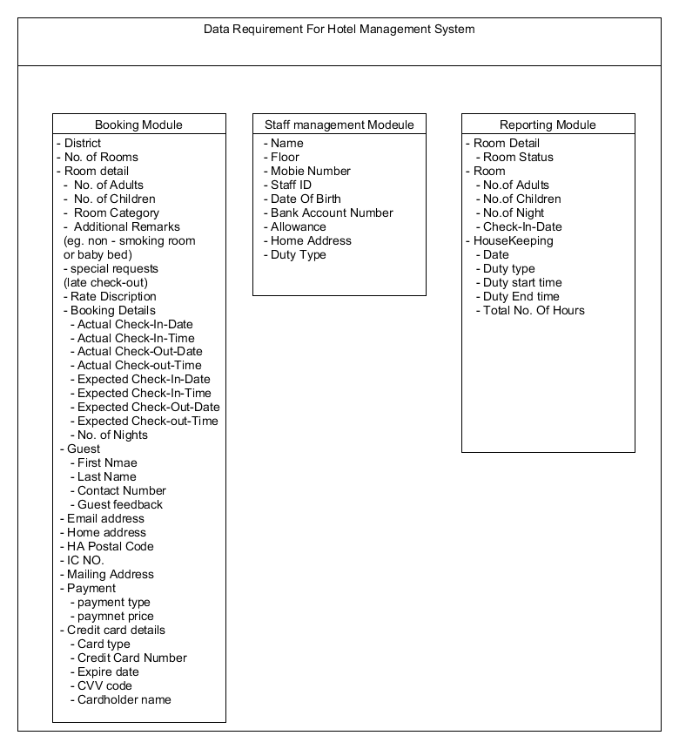

User Interface Requirements
With consideration of the required and wanted functions and features in the system, we have drafted out a UI (user interface) flow diagram to roughly depict how to navigate around the graphic UI which in this case is Delonix Regia Hotel’s website.

Here shows the navigation and the homepage of the User interface of our website:

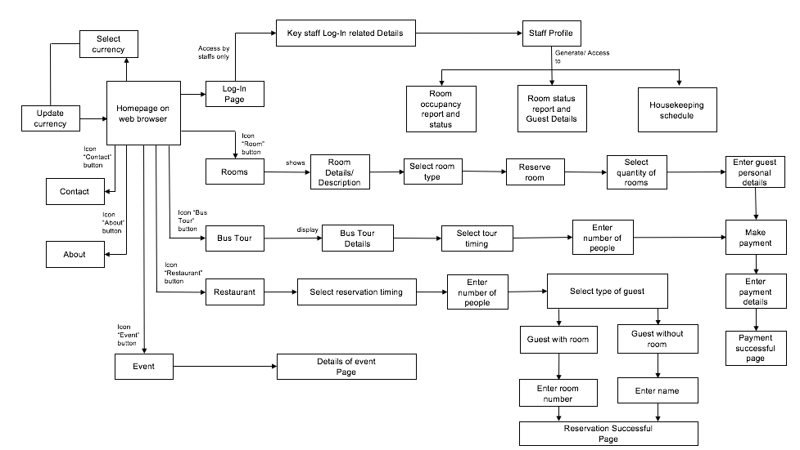

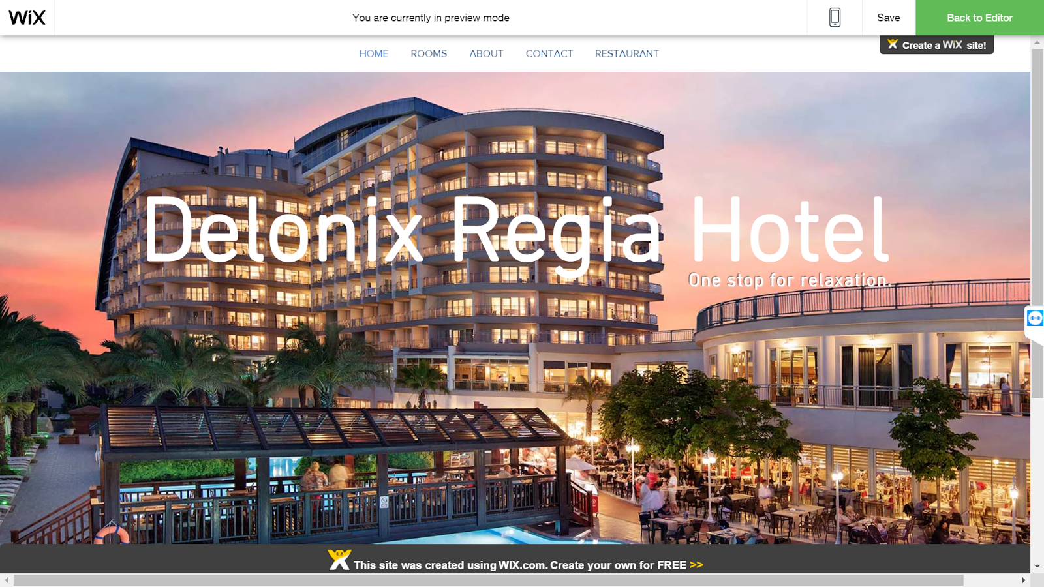

Interface with Other Systems
Interface with other systems refers to the interaction of one system with the other within a website (in our case). This interaction would mean that systems can share their data with each other seamlessly even though they belong to different departments.

Things like reservation of tables and other facilities, need to tally in the reporting module and staff should be able to see it when they need it, instead of manually checking reservations.

Housekeeping services should also be able to see if there are any updates on the rooms that have been cleaned up already and any room service if needed. Therefore, having the systems communicate with each other would mean that important information (customer’s information) is being transferred only within the company. Hence, with Mr Wang’s concern over security in mind, all data transferred between the server and individual computers can use the Transmission Control Protocol/Internet Protocol (TCP/IP) over an Ethernet connection which is a communication protocol in a private network. This ensures that the network is closed and not accessible using the internet, preventing unauthorized access to confidential data.

Assumptions
- Assume that the hardware components of the user meet a certain specification
- Assume that Ethernet connection is available
- Assume that every staff profile displays info unique to their field of work and department
- Assume that the staff has a unique company based email address assigned to them to indicate during the Log-in process to ensure the login directs the staff members to a employee profile

OPERATIONAL AND QUALITY REQUIREMENTS

Operating Environment
From the interview, we found out that the current computer is running on Windows XP2 that supports Service Package. Therefore, the environment that we are planning use is an upgrade of the system to Windows 7. The latest Service Pack is Service Pack 1. With this improvement, Mr Wang would be able to keep PC up-to-date, meet users’ demands for greater business mobility and provide an easier Service Pack deployment model for better IT efficiency. For this we would require Windows 7 and Windows Server 2008 R2.

Development Constraints
Time constraint
As the given time for the development of the system is short. Therefore, a time constraint may occur if there is a problem in developing the system.

Budget constraint
As the given budget for the development of the system is limited. Therefore, a budget constraint may occur if there is a change in developing the system.

Performance
The screen should able to display the website in 2 second. The user should be able to add a room to the cart in less than 2 seconds. He/she should also be able to view information about that room in less than 5 seconds. Then the user should be able to enter the number of rooms, adult and children in 5 seconds. The user should also be able to select the check-in date and the check-out date in less than 5 seconds. He/she should be able to check out the chosen room in the cart within 5 seconds after completing the booking form. The system should able to prompt the successful notification to the user in 1 second. During peak hours, the response time may increase 2 seconds. Overall, the maximum response time to book a hotel room will be 1 minute.

Therefore, four requirement points for performance,
- The load time for user interface screens shall take no longer than two seconds
- The log in information shall be verified within five seconds
- Queries shall return result within five seconds
- Maximum response time to book a hotel room will be 1 minute

Availability
The system is required to run 24 by 7. The acceptable downtime for maintenance and data backup would be during the non-peak hours at 2-3am. Data backup would be done monthly, on the last day of each month. Also, the backup records would be kept in the system for at least 3 years after which it can be safely discarded. Maintenance would be done fortnightly, on the 2nd Sunday. For instance, in the month of June, maintenance would be done on Sunday, 18th June and the following would be on the last day of June, Friday the 30th.

Security and Access Control Requirements
Access Control

Modules | Accessed By
Room Availability and Booking module | Reception staff  Management users  Hotel Administrator (Mr Wang)
Housekeeping and Staff management module | Management users  Hotel Administrator (Mr Wang)
Reporting module  1) Room Status report  (eg: room 401 is vacant)  2) List all guests in one room (eg: 2 adults 2 child in room 401)  3) List all guests in all rooms (eg: Total of 200 adults and 30 children check-in on 23 May 2016)  4) Room Occupancy report (generate statistics)  5) Housekeeping report (eg: Mary’s, a staff, duty is general maintenance) | Reception staff - All except Room  Occupancy and Housekeeping report  Management users – All reports  Hotel Administrator (Mr Wang) - All reports
User account and login creation module | Hotel Administrator (Mr Wang)

Security

Data Transfer | - The system should use secure sockets in all transactions that include any confidential customer information.  - The system should automatically log out all customers after a period of inactivity.  - The system should confirm all transactions with the customer’s web browser.  - The system shall not leave any cookies on the customer’s computer containing any of the user’s confidential information.
Data Storage | - The customer’s web browser should not display a customer’s credit card number after retrieving it from the database. Only the last 4 digits of the credit card number should be shown.  - The system’s back-end servers should only be accessible to authenticated administrators.  - The system’s back-end database should be encrypted.

SPECIAL REQUIREMENTS

Bus Tour
For the convenience of all guests, our hotel provides tours by bus around the city that all guests of the hotel can book through the website. Guests are able to choose time slots that they prefer for their tour and pay upon check out.

Room Availability
Hotel’s staff (especially receptionist) and guests are able to check the availability of a particular room. To check availability status, users have to enter check-in and check-out dates. The next page would display the results of the status of the room.

REFERENCES

- http://smallbusiness.chron.com/differences-between-time-constraints-resource-constraints-project-35756.html
- https://www.symantec.com/connect/blogs/how-successfully-protect-transfer-sensitive-data
- https://en.wikipedia.org/wiki/Secure_transmission

